Debugging

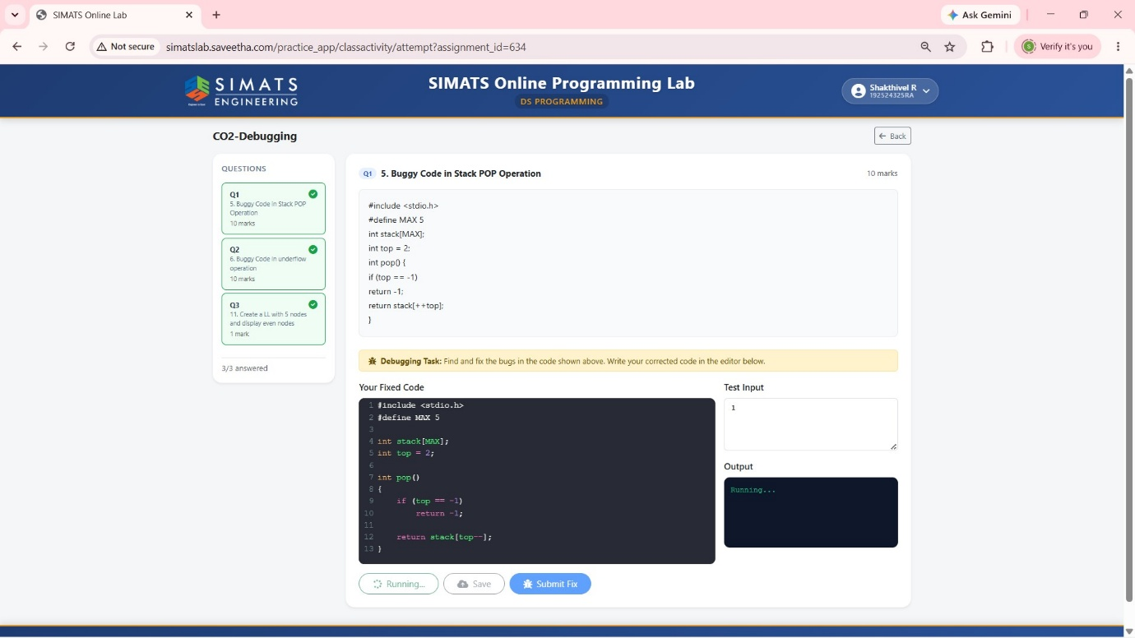
1)Buggy Code in Stack POP Operation

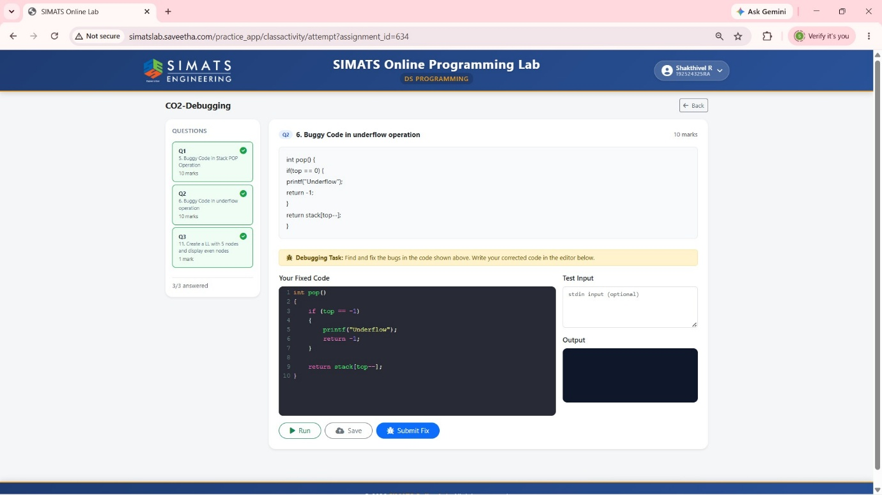
2)Buggy Code in underflow operation

3) Create a LL with 5 nodes and display even nodes

